**Assignment2**

**Step 1:** Begin by using 12 Boolean indicators to represent the four sets of traffic lights at an intersection. Set four of these indicators to red, four to yellow, and four to green.

Next, assign 12 numerical display controls to show the timing of each indicator's activation. Use a switch assembly to control the entire traffic light system.

Then, since the sequence of the lights is predetermined—starting with green, followed by yellow, and then red—the green light should last for 9 seconds, the yellow for 1 second, and the red for 10 seconds. Implement a sequential structure to manage the alternating of lights accordingly.

Finally, use condition checks (true/false) to control the system. When the switch is on, the condition is true, and the traffic lights operate. When the switch is off, the condition is false, stopping the system.

**Step 2:** Add two additional controls to the interface to allow users to adjust the traffic flow duration for each road. Set the green light time to be adjustable between 5 to 30 seconds. Ensure that the north-south and east-west traffic lights are synchronized so that both sides don't display green at the same time. Include an emergency switch that, when activated, turns off all red and green lights while making the yellow lights flash continuously (0.5 seconds on and 0.5 seconds off). When deactivated, the lights return to normal operation without delay.

**Step 3:** Improve the system's visual layout by using a diagram of the intersection. Adjust the controls for a more realistic and user-friendly interface.

**Step 4:** Add 20 LED lights on the road to represent cars waiting or moving through the intersection. A moving car can be simulated by sequentially turning off one LED and turning on the next as it moves. Vehicles stop and wait at red lights, ensuring they don't block intersections. Additionally, provide a speed controller on the interface, allowing the user to adjust the car's speed between 1 and 5. When the emergency mode is active, all vehicles stop at the intersection and wait for the emergency to end.

**Question:** How would you modify your simulator to model the average waiting time of cars at theintersection with various green light intervals, given the number of cars crossing the intersection per minute(in each direction) and their average speed?

To implement this, modify the simulator to include a timer that adjusts the green light duration, allowing it to accept varying values. This parameter can be set as user input on the simulator interface. In the simulator's main loop, track the number of cars passing through and their average speed, while simultaneously recording each car’s waiting time. After each red light cycle, calculate the average waiting time by dividing the total wait time by the number of cars waiting during that cycle. Display the results for the user.

With these changes, the simulator can model average waiting times under different conditions by adjusting the green light intervals. The user can observe how the green light duration impacts the average wait time for vehicles.

The front panel picture of the entire system is as follows:

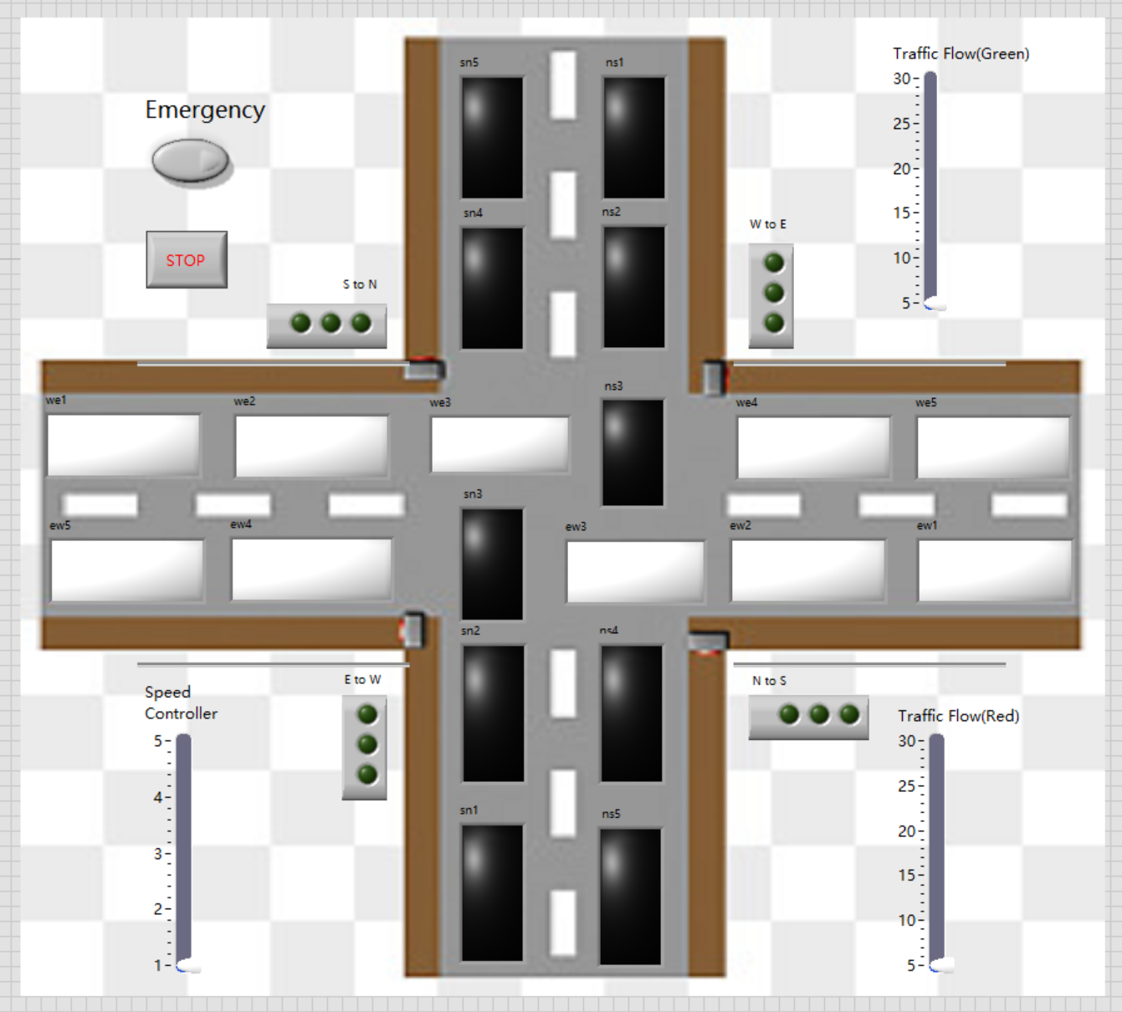

The block diagram of the entire program has five parts, which are shown as follows:

